Orchard View Early Elementary: Kindergarten Students in Mrs. Cobb’s class

**Butterfly Pollinator Garden**

About the Project**:**

Mrs. Cobb’s Kindergarteners learned about butterflies and other pollinators. They realized that we could help pollinators in our area by planting a butterfly garden.

Students researched the **life cycle** of butterflies and the plants that were needed at each stage of life. That helped to select **native plants** for out garden.

Students learned about what plants need to survive and thrive, so once our plants arrived they were ready to plant our garden.

With the help of our **custodian**, we were able to select a location and clear it for planting.

Students spent a day in May planting native plants that would be loved by butterflies at the Orchard View Early Elementary. In June, we spent time adding mulch. We were also able to add a sign to inform visitors about our garden!

We then watched as eight caterpillars formed chrysalises and turned into **Painted Lady Butterflies**. We released them into our garden!



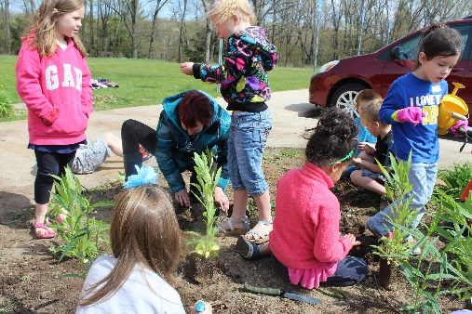

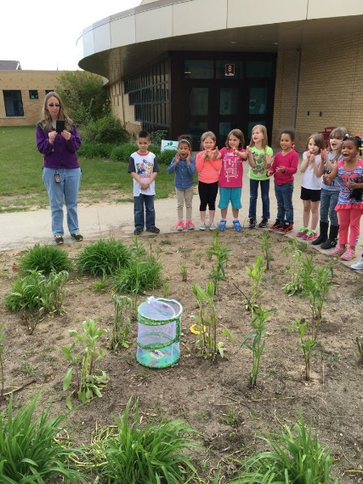

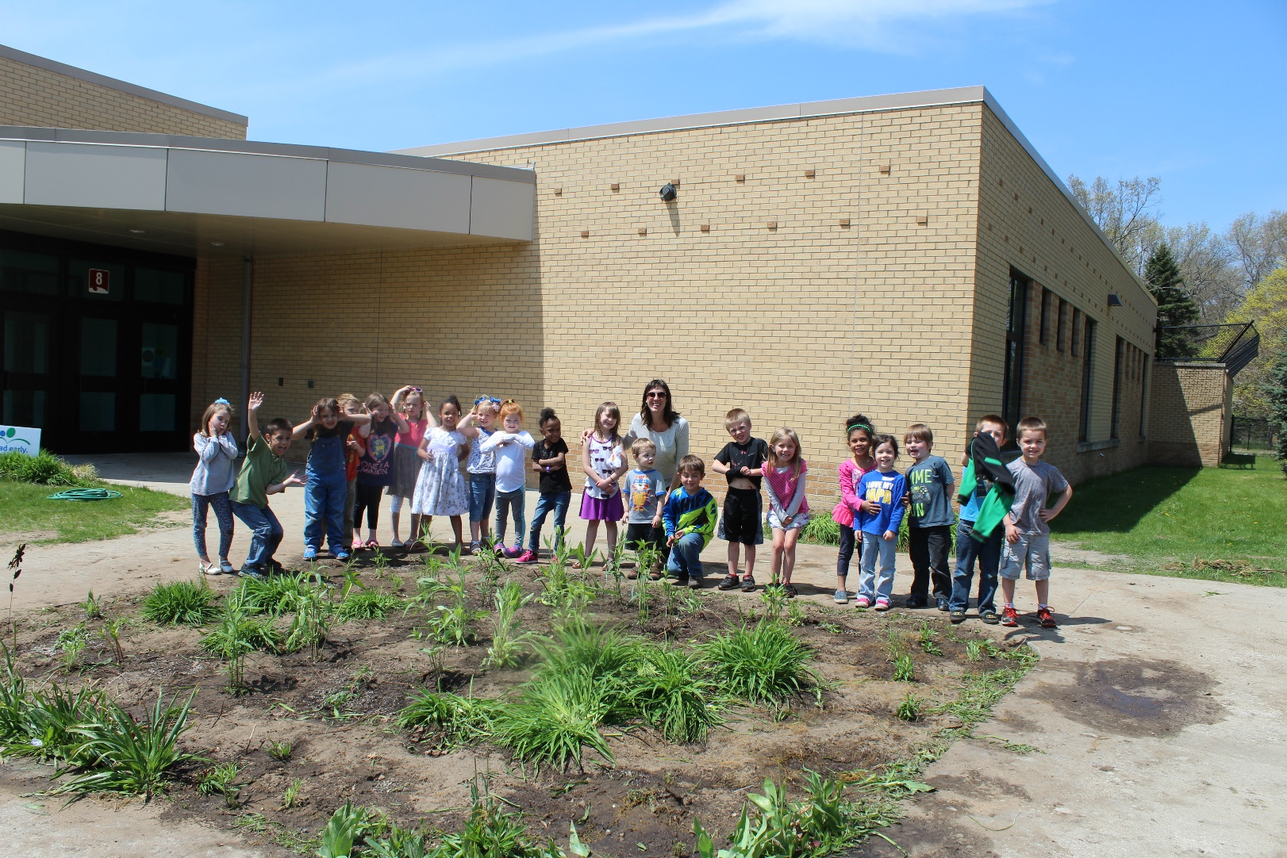

**Students Learn**: Butterflies and caterpillars need specific plants to thrive.

**Community Partners**:

Inna Klein (School Principal)

Larry Lazarock (School Custodian)

**Fall 2015**:

Students learn about butterflies and their life cycle.

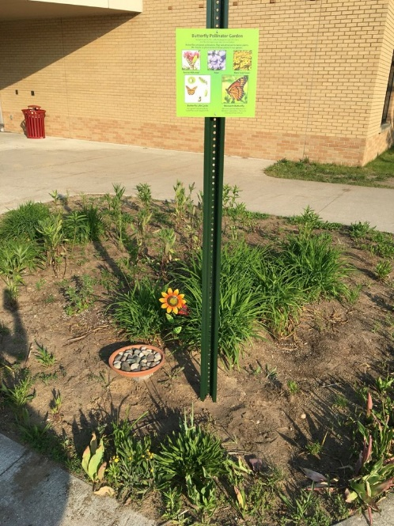

**Spring 2016**:

Mrs. Cobb and parents helped to plant and care for our butterfly pollinator garden!

**Winter 2015-16**:

Students planted mini greenhouses with butterfly pollinator plants. We placed them outside to go through several freezes.

